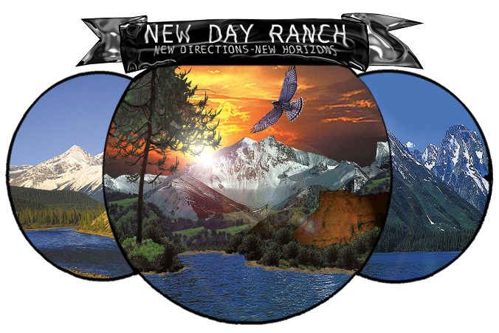 |  | New Day,Inc.  Level III.I  Braided Circle  - Recovery Home
Braided CIRCLE |  | In This Issue
Level III.I Women’s Residential Recovery Home
New Day, Inc. has expanded services to include a 90-day Women’s Recovery Home for female clients who meet ASAM criteria for this Level of Care.

The first step in obtaining services is to schedule an appointment for a chemical dependency evaluation. Or, if a chemical dependency evaluation has been done in the past six months, just call our office and talk to a Licensed Addiction Counselor about our outpatient group treatment options. Pregnant women receive priority access to services.

by [Article Author]
The typical functional limitations found in populations typically treated at a level III.1 include problems in the application of recovery skills, self-efficacy, or lack of connection to the community systems of work, education, or family life. In a setting that provides 24-hour structure and support, residents have an opportunity to develop and practice their interpersonal and group living skills, strengthen their recovery skills, reintegrate into the community, family, and begin to resume employment or academic pursuits.
Treatment at this level of care sometimes is warranted as a substitute for or supplement to deficits in the patient’s recovery environment, such as a chaotic home situation; drug using family or significant others, caretakers, or siblings; or a lack of daily structured activity (such as school or work). In other cases, it may be the patient’s functional deficits (including developmental immaturity, co-occurring conditions, greater than average susceptibility to peer influence, poor impulse control.

Services:
Examples of Recovery Home services include:
♣ Services designed to improve the patient's ability to structure and organize the tasks of daily living and recovery, such as personal responsibility, personal appearance, and punctuality ♣ Planned clinical program activities for at least five hours per week of professionally directed treatment ♣ Activities may include relapse prevention, exploring interpersonal choices, and development of a social network supported or recovery ♣ Addiction pharmacotherapy ♣ Random urine screening to monitor and reinforce treatment gains

The first step in obtaining services is to schedule an appointment for a chemical dependency evaluation. Or, if a chemical dependency evaluation has been done in the past six months, just call our office and talk to a Licensed Addiction Counselor about our outpatient group treatment options. Pregnant women receive priority access to services.

Contact Us:

New Day, Inc.
Adult Substance Abuse Treatment
1724 Lampman Dr.
Billings,MT. 59102
(406) 869-0793
Fax # (406) 294-2332
dleclair@newdayranch.com
lfuller@newdayranch.com
pwhiteman@newdayranch.com
ksnyder@newdayranch.com
dwoodenlegs@newdayranch.com
pjustice@newdayranch.com

